Geometry
Winter Student Enrichment Packet
Answer Key

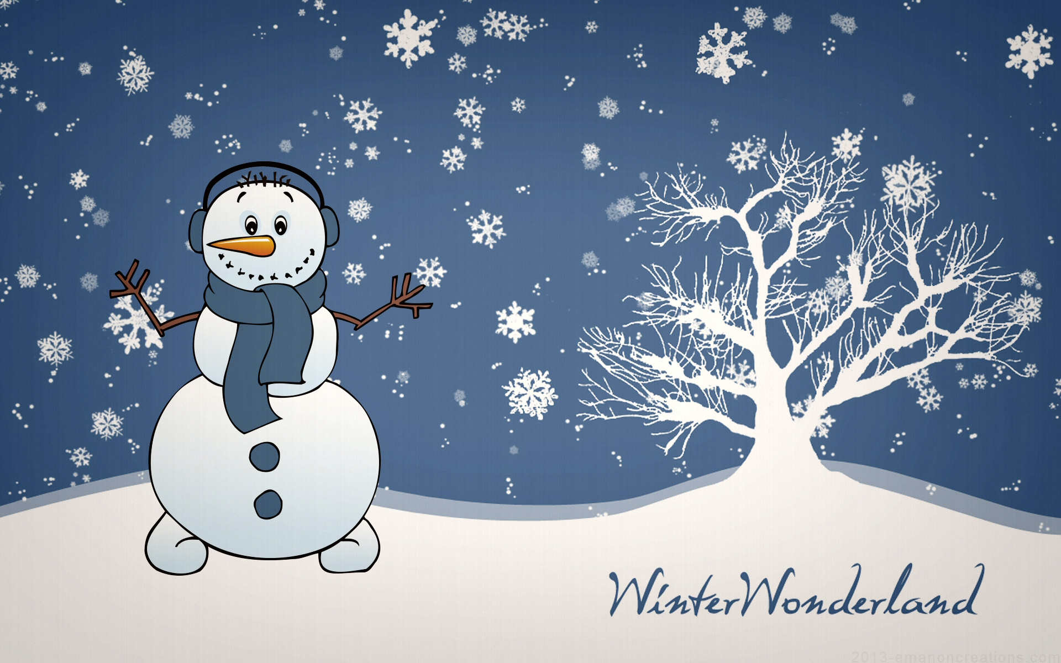
Prince George’s County Public Schools
Office of Academic Programs
Department of Curriculum and Instruction

™

NOTE TO STUDENT

This Winter Student Enrichment Packet has been compiled to complement high school mathematics classroom instruction aligned to Maryland College and Career- Ready Standards (MCCRS). It is intended to be used for review and practice of previously taught and new concepts.

We strongly encourage you to work diligently to complete the activities in this packet. You may experience some difficulty with some problems in this packet, but we encourage you to explore and attempt to find a solution to the best of your ability.

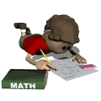

Playground Fun

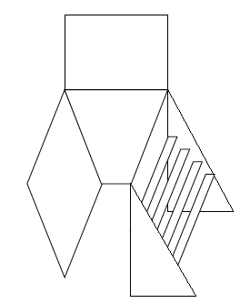 | 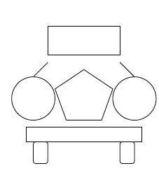
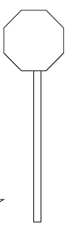 | 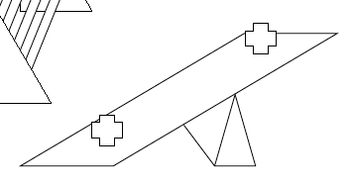
- Examine the scene of the playground above. There are a lot of different shapes that make up the toys and play equipment. Draw, name, and describe clearly all the shapes you can see in the playground picture. Answers may vary.

- Lisa and Jim are drawing pictures to give to friends. Lisa made a drawing using different shapes and line of symmetry. She used the folded edge as the line of symmetry. Draw a picture of what the paper will look like when it is unfolded.
Answers may vary.

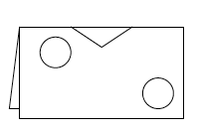 | 

- Jim made a drawing with 5 shapes in all. When it was finished, he noticed the following:
- his drawing had one line of symmetry
- he drew 4 shapes that had 4 corners
- he drew 1 shape that had 3 corners

Show what Jim’s drawing could have looked like. Explain why you drew the drawing you did.
Answers may vary.

4. You work for a company in its marketing department. It is your job to create a new company logo. You have heard that having a logo with rotational symmetry is attractive and useful for potential customers. You look through a page of company logos. Which of the logos below have rotational symmetry? Explain your findings.

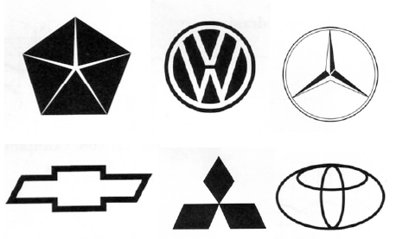

Explain why a logo with rotational symmetry is attractive and useful for potential customers.

Answers may vary.

Create a new logo with rotational for your company.

Answers may vary.

Illustrate all the line of symmetries of your logo. Justify why your logo has rotational symmetry. Answers may vary.

