Math 8
Spring Student Enrichment Packet



PRINCE GEORGE’S COUNTY PUBLIC SCHOOLS
Office of Academic Programs
Department of Curriculum and Instruction



NOTE TO THE STUDENT

This Spring Break Packet has been compiled to complement middle school mathematics classroom instruction aligned to the Maryland College and Career Ready Standards (MCCRS). The packet is intended to be used for review and practice of previously taught and new concepts.


The questions in this packet, which have the corresponding Maryland College and Career Ready standard listed next to them, are similar to those you will encounter later this year on the PARCC assessment. See more resources for PARCC at www.parcconline.org.

We strongly encourage you to work diligently to complete the activities. You may experience some difficulty with some activities in this packet, but we encourage you to think critically and creatively and complete them to the best of your ability.

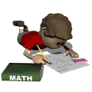

Use this Assessment Reference Sheet as needed as you solve the problems in this packet.

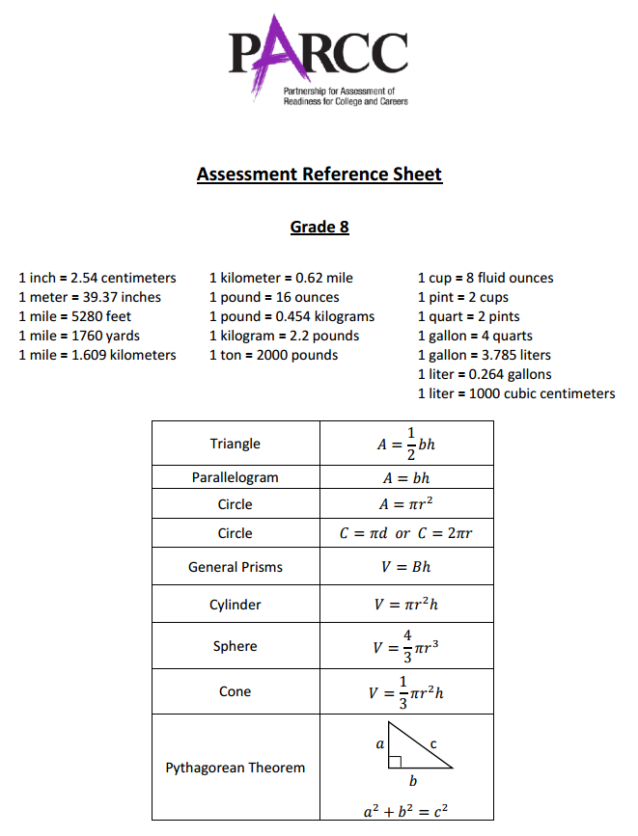

Directions: Select or find the best answer to each problem. Write your answer in the space provided or on a separate sheet of paper.

1. (8.EE.1)
Six expressions are shown. Circle which expressions are equivalent to$6^{8}×6^{-4}$.

$$6^{(8-4)}$$ | $${{(6}^{8})}^{-4}$$ | $$6^{2}$$ | $$6^{-2}$$ | $$6^{-32}$$ | $$\frac{6^{8}}{6^{4}}$$

2. (8.NS.2)
The length of a diagonal of a rectangle is $\sqrt{213}$ inches. Plot a point on the number line below that best approximates the location of $\sqrt{213}$.

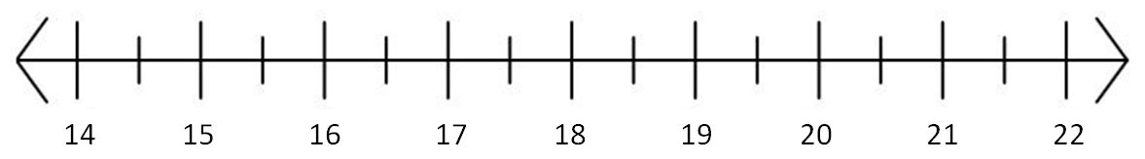

3. (8.EE.2)
Which of these expressions represent solutions to the equation $n^{3}=27?$ Select each correct answer.

□ A. 3
□ B. –3
□ C. 9
□ D. –9
□ E. $\sqrt[3]{27}$
□ F. –$\sqrt[3]{27}$

4. (8.NS.1)

What fraction is equivalent to $0.27$ ? Write your answer in the boxes.



5. (8.EE.4)

A painter bought 750 paintbrushes. Each paintbrush has a mass of $5.2×{10}^{-3}$ kilograms. What is the total mass in kilograms of the paintbrushes that the painter bought? Write your answer as a decimal in the box.

kg

6. (8.EE.1)

Which expression is equivalent to $\frac{3^{-2}}{3^{-4}}$ ?

A. $3^{2}$
B. $\frac{1}{3^{2}}$
C. $3^{6}$
D. $\frac{1}{3^{6}}$

7. (8.EE.3)

Rewrite the number 5,616,000 in scientific notation. Fill in the blanks to complete the expression below.

x 10

8. (8.G.9)
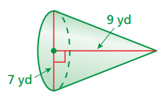

Find the volume of the cone.

A. $16π$
B. $36.75π$
C. $63π$
D. 147$π$

9. (8.EE.1)

Which expressions are equivalent to ${(5^{2})}^{3}∙5^{4}$?

Select each correct answer.

□ A. $5^{2∙3∙4}$

□ B. $5^{2∙3+4}$

□ C. $5^{2+3+4}$

□ D. $5^{2(3+4)}$

□ E. $5^{2∙3 }∙5^{4}$

□ F. $5^{2+3 }∙5^{4}$

10. (8.EE.4)

This table shows the populations and land areas of the five most popular countries in the world.
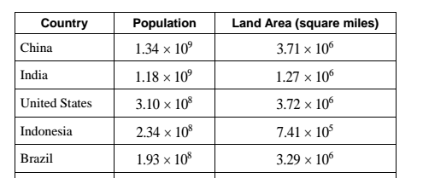

Part A
What is the combined total land area of the United States and China? Write your answer in standard form.

Part B
Karen says that Indonesia has the largest land area because 7.41 is the largest number of all those listed first in the Land Area column.

Karen is incorrect. Use what you know about scientific notation to explain why she is incorrect and determine which country in the table has the largest land area.

11. (8.G.9)

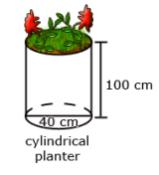
The cylindrical planter above has a diameter of 40cm. Its volume is $40,000π$ cubic cm. If a larger planter has a diameter that is twice the length of the one above but the same height, what is the volume of the larger planter? Show your work or explain how you determined your answer.

12. (8.EE.2)

If $m^{2}=\frac{81}{16}$, what is the value of m?

A. $\frac{9}{4}$

B. $\frac{162}{32}$

C. $\frac{40.5}{8}$

D. $\frac{81}{16}$

13. (8.EE.4-2)
Tara entered the mass, in kilograms, of four quantities into a spreadsheet. Her spreadsheet automatically converted the masses into scientific notation.

Quantity | Mass (kg)
Quantity A | 8.2 E5
Quantity B | 6.235 E6
Quantity C | 5.77 E4
Quantity D | 3.7 E5

Which list shows the four substances in order from least mass to greatest mass?

A. Substance A, Substance B, Substance C, Substance D
B. Substance D, Substance C, Substance B, Substance A
C. Substance C, Substance A, Substance D, Substance B
D. Substance C, Substance D, Substance A, Substance B

14. (8.EE.4-1)

A spacecraft leaves Earth at a speed of $6×{10}^{4}$ km per day. To travel from Earth to Saturn, the spacecraft needs to travel a total distance of $1.2×{10}^{9}$ km. How many days will it take for the spacecraft to reach Saturn? Enter your answer in the blank.

days

15. (8.G.9)

The games of baseball and softball are similar, but a baseball is smaller than a softball.

The diameter of a baseball is 3 inches, while the diameter of a softball is 3.8 inches. How much greater is the volume of a softball than the volume of a baseball? Use 3.14 for pi.

A. About 11 cubic inches

B. About 13 cubic inches

C. About 15 cubic inches

D. About 17 cubic inches

