SPRING STUDENT ENRICHMENT PACKET
RESEARCH SIMULATION TASK
& READING LOG
Grade 6
BIGFOOT ENCOUNTERS
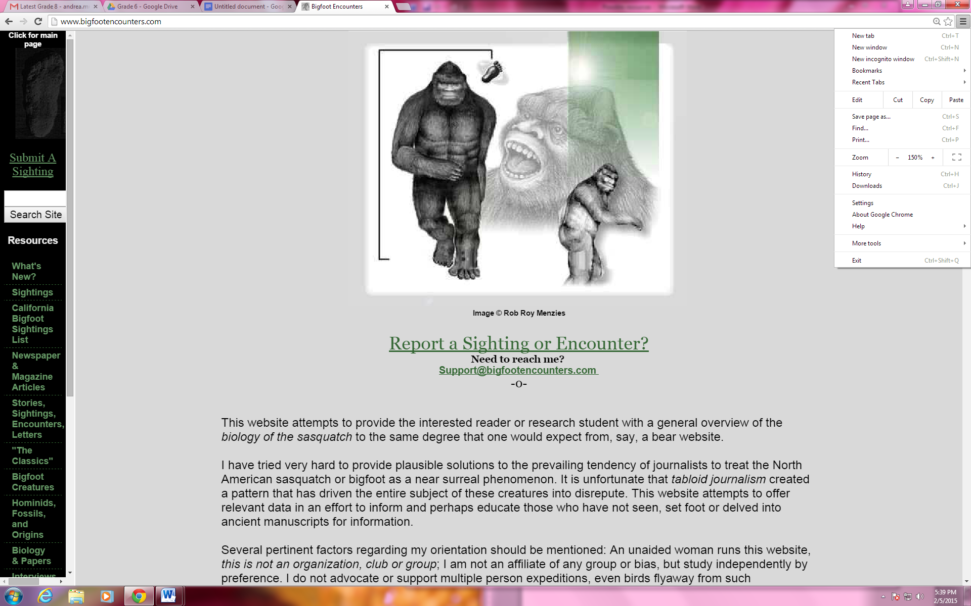
Reading/English Language Arts

™

Prince George’s County Public Schools
Office of Academic Programs
Department of Curriculum and Instruction

[Type the company address]
Note to Students:
You've learned so much in school so far! It is important that you keep your brain active over the break. In this package you will find a calendar of activities to last you all Spring Break. This year we have also incorporated a fun project for you to complete. Once you have completed the activity, create a journal that you can use to note your thoughts, ideas, and any work you complete.

Directions:
Family members should preview the packet together. There are activities that may require advance planning, or you may want to consider working together with other family and friends on some activities.

- Students should read for at least 30 minutes each day.
- Students will need a Reader’s & Writer’s Journal to complete this spring work. Your journal will be your special place for your daily calendar work and writing. Students can purchase a journal or they can make one by stapling several pieces of paper together or by using a notebook/binder with paper. Students should be creative and decorate the journal. Specific journal tasks are given some days, but students may also journal after each day's reading, notice things that stood out, questions that they have, or general wondering about the text.
- Each journal entry should:
- have the date and assignment title;
- have a clear and complete answer that explains the students thinking and fully supports the response; and
- be neat and organized.
- Use the chart in this package to record all of the books read during Spring Break.



READING LOG

Ideally, students in the middle grades should read for 30 or more minutes each day.

All good books are alike in that they are truer than if they had really happened and after you are finished reading one you will feel that all that happened to you and afterwards it all belongs to you…  Ernest Hemingway  Esquire, December 1936 |  |  | Day 1  Pages Read:  Amount of Time: | Day 2  Pages Read:  Amount of Time: | Day 3  Pages Read:  Amount of Time: | Day 4  Pages Read:  Amount of Time:
Day 5  Pages Read:  Amount of Time: | Day 6  Pages Read:  Amount of Time: | Day 7  Pages Read:  Amount of Time: | Additional  Pages Read:  Amount of Time: | Additional  Pages Read:  Amount of Time: | Additional  Pages Read:  Amount of Time: | Additional  Pages Read:  Amount of Time:

Looking for a “novel” idea? Browse your bookshelves at home for a title, or visit your local library or bookstore for a great read! If you need some ideas, a few authors are listed below.
  - Avi
  - Virginia Hamilton
  - Lois Lowry
  - Louis Sachar

Do you prefer nonfiction? Browse your bookshelves at home for a title, or visit your local library or bookstore for a great informational text.

  - From your World Cultures studies
  - From your Science studies
  - Current events (such as presidents and political races or global warming and other environmental issues)
  - Biographies of interesting people

Are you still looking for ideas?

  - Prince George’s County Memorial Library suggested reading lists by grade – http://www.pgcmls.info/website/childrens-graded-reading-lists-442
  - Metametrics’ Lexile website – http://www.lexile.com/fab/

Introduction
Documented sightings of the North American Bigfoot date back to the 1830s, and interest in Bigfoot grew rapidly during the second half of the 20th century. This was encouraged by many magazine articles—and even a film!—of the time describing the discovery of large, mysterious footprints the year before in Bluff Creek, California. A half century later, the question of Bigfoot’s existence remains open to many people.
In this series of tasks, you will research different media sources related to the existence of the massive creature commonly known as Bigfoot. You will see how different sources choose to present their information in diverse ways.

First, you will read a pair of encyclopedia articles that provide general information. Then, you will view and read a website that examines the evidence around the existence of the Bigfoot. Finally, you will examine two newspaper articles that share people’s experiences with Bigfoot sightings (including one here in Maryland!).

As you review these sources, think about the advantages and disadvantages of using different mediums (for example, print or digital text, video, multimedia) to present a particular topic or idea.

HINT: Keep this information in mind as you review each source! It will be helpful, not only for each text but for the final task, too!

Research Simulation Task Texts
Three texts will be used in this set of practice materials.
- Text 1: Entries from Encyclopedia Britannica Online, and Wikipedia (online encyclopedias) at:
  - http://www.britannica.com/EBchecked/topic/1481/Abominable-Snowman
  - http://en.wikipedia.org/wiki/Bigfoot

Text 2: “10 Reasons Why Bigfoot's a Bust” (website, print text provided)

Text 3: “Man or Gorilla” and “Monster Hunt Grows” (newspaper articles)

Research Simulation Tasks
For this task, you will complete questions related to each text noted above. Then you will complete an Analysis Project that is based on at least two of the three texts.

TEXT 1

Please read the encyclopedia entries at the pages at the links below. Then answer questions 1 - 4.

http://www.britannica.com/EBchecked/topic/524755/Sasquatch

http://en.wikipedia.org/wiki/Bigfoot

1. Part A – Vocabulary
From the Encyclopedia Britannica, what does the word alleged mean?
- Something that is doubtful, supposed, or is suspicious
- A narrow, shelf-like ridge or line of rocks; like a reef
- That which tends to prove or disprove something such as data
- To state to be true, especially in legal use or after giving an oath

Part B
Which phrase from the website best supports the correct answer in Part A?
- “the North American counterpart of the Abominable Snowman”
- “none of the purported evidence has been verified”
- “described as a primate ranging from 6 to 15 feet”
- “most scientists do not recognize the creature’s existence”

2. Part A.
Why do the editors of the Wikipedia text include a table of contents for this entry?
- It gives all the details that a reader is looking for about the Bigfoot, Sasquatch, and Yeti.
- It lists all of the sources, or bibliographical resources, the editors used to create this entry.
- It organizes the information to make it easier for the reader to find what he or she needs.
- It helps the reader identify any infographics that help the reader visualize information.

3. Below is an important idea from the Wikipedia section titled “After 1958.”

Modern technology and communications have helped fuel the rumors of the existence of Bigfoot.

Drag and drop the two lines from the text that best support this idea into the boxes below. If you are working with a paper version, copy the two lines into the boxes below.

1. | 2.
A. “Locals had been calling the unseen track-maker "Big Foot" since the late summer, which Humboldt Times columnist Andrew Genzoli shortened to "Bigfoot" in his article.”
B. “Eric Shipton photographed what he described as a Yeti footprint, which generated considerable attention and led to the story of the Yeti entering popular consciousness.”

E. “Locals had been calling the unseen track-maker "Big Foot" since the late summer.”
D. The notoriety of ape-men grew over the decade, culminating in 1958 when large footprints were found in California.
C. “Bigfoot gained international attention when the story was picked up by the Associated Press.”
4. What are advantages and disadvantages of this format to present information? Use this graphic organizer to organize your thoughts about the advantages/disadvantages of the format of this form of media.

http://www.worldbookonline.com/student/article?id=ar059170&st=sasquatch,
http://www.britannica.com/EBchecked/topic/1481/Abominable-Snowman, and
http://en.wikipedia.org/wiki/Bigfoot

Media format

 | Evidence/Detail | Explanation/Importance
Advantages of this format to presenting information | 1:
Advantages of this format to presenting information | 2:
Advantages of this format to presenting information | 3:
Advantages of this format to presenting information | 1:
Advantages of this format to presenting information | 2:
Advantages of this format to presenting information | 3:

TEXT 2

Please read and review the ten slides of this web article: http://news.discovery.com/animals/endangered-species/10-reasons-why-bigfoots-a-bust-140526.htm. You may choose to read the version below.

Then answer questions 5 – 8.

10 Reasons Why Bigfoot's a Bust
MAY 26, 2014 07:00 AM ET // BY DISCOVERY NEWS

The Empty Fossil Record
When two Georgia men declared they were storing the body of Bigfoot in a freezer -- and that they had its DNA -- more than a few skeptics cried foul.
Is the legend of Bigfoot (a.k.a. Sasquatch) little more than a stubborn myth? For the dirt on the doubters, Discovery News contacted Benjamin Radford, deputy editor of Skeptical Inquirer magazine, who was more than happy to rattle off the top 10 reasons Bigfoot is bogus.
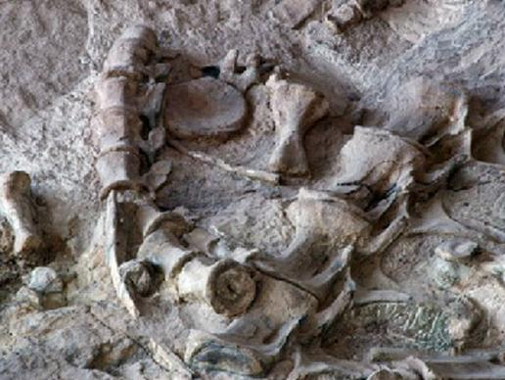
Getty Images
First on his list: the fossil record. Why, he asked, would a legacy of large mammals reported to exist throughout North America (and beyond) simply disappear from the same soil that has preserved everything from the dinosaur bones pictured here, to woolly mammoths, to tiny marine crustaceans?
"There's no fossil record of anything fitting the description" of Bigfoot, said Radford. "There's simply nothing there."
Forget Fossils, Where Are the Bodies?
Putting aside paleontology, Radford points out that today, if Bigfoot exists, it must disappear when it dies. "There's no hard evidence in the form of bones. There are no hair samples, there are no live or dead specimens," he said.
Bigfoot believers argue that the soil in areas where the creatures live -- such as the region surrounding Bellingham, Wash., seen here -- is acidic and quickly breaks down the bones. Nonsense, says Radford: "There's nothing to that, because Bigfoot has been reported in every state but Hawaii."
Where Do Bigfoot Babies Come From?
Even for mammals that are relatively rare in global terms, such as the chimpanzee, it takes a decent population size to maintain a species. "If Bigfoot is a zoological reality," said Radford, "there has to be a breeding population."
For that population to be big enough to account for even a fraction of the sightings there would need to be tens of thousands of the creatures in North America alone. "Think about that for a second. Tens of thousands of Bigfoot, living, breathing, doing what they do. Where are they? Why don't they get hit by a car?" asked Bradford. "The numbers just simply don't add up."
Your Lying Eyes
The majority of "evidence" for Bigfoot, says Radford, consists of eyewitness accounts. Yet as psychologists and schooled juries know, such accounts are famously inaccurate.

New 'Bigfoot' Sighting Latest in Series of Hoaxes (external link)

What's more, says Radford, "the problem is, that's not evidence, it's an anecdote....It's interesting and you shouldn't dismiss it out of hand, but it's not evidence."
The Ever-Mysterious Blobsquatch
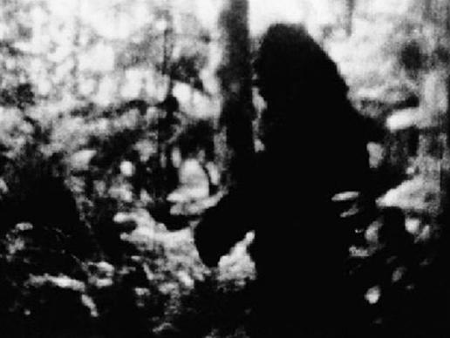
AP Photo
This black-and-white image was taken in 1977 by a man named Frank White, near Bellingham, Wash. "I'd call it a North American ape," White told reporters at the time. "You can call it a Sasquatch or anything you like."
Radford calls it a “Blobsquatch.” Aside from eyewitness reports, blurry images like this are what most Bigfoot believers rely on.
But it's no proof, said Radford: "These photos show something that is probably alive, it's probably dark, it's not a cat, it's not a camel. It could be a Bigfoot, or it could be a deer or it could be a guy in a suit."
"Ultimately," he concludes, "it's a two-dimensional image. It's pixels."
Doctor Who?
For Radford and other skeptics, the only acceptable standard of proof is the scientific one. Why, when there are countless researchers probing the far corners of every continent, is there no rigorous, documented, peer-reviewed evidence for Bigfoot? Only one answer makes sense, says Radford: Bigfoot isn't real.
Attendees of the Texas Bigfoot Conference, pictured here, might disagree. The annual event draws hundreds of people -- including Bigfoot enthusiasts, amateur researchers, historians, and tourists -- but few if any academic scientists.
The Case of the Ivory-Billed Woodpecker
Speaking of science, Bigfoot believers sometimes complain that funding for Sasquatch Studies is hard to find. But scientists are notoriously good note-takers, Radford points out, even about subjects they aren't directly studying.
Consider this league of biologists scouting for the elusive ivory-billed woodpecker in Arkansas' White River National Wildlife Refuge, an area where Bigfoot sightings have been made.
"There was a huge, hardcore investigation. They were well-equipped, well-funded and made a sustained search," noted Radford. "What I found interesting was, what didn't they find? They didn't find Bigfoot."
This Katydid Couldn't Hide
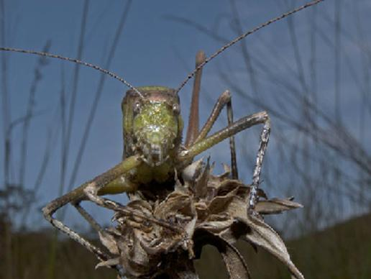
Getty Images
Dozens of new species, previously unknown to science, are discovered each year. But for the most part, they are tiny: micro-organisms and insects such as the newly discovered katydid pictured here. Could Bigfoot really hide in such a peopled world?
"The last large animal to be found was probably the giant panda, and that was 100 years ago," said Radford. "There has not been a single new creature that doesn't fit the recognized taxonomy discovered in the last century, there just simply hasn't."

If It Walks Like a Hoax ...
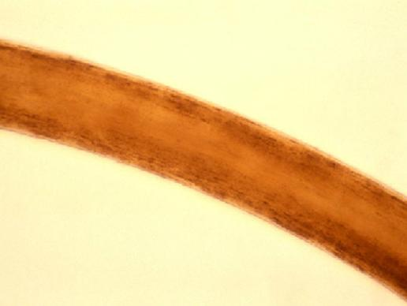
This ruddy strand, about 70 micrometers in diameter, could be taken as a hair. But it isn't -- it's a carpet fiber.
A similar thread was once claimed to have fallen from Bigfoot's back. Later, it was shown to be synthetic Dynel fiber, said Radford. An alleged vial of Bigfoot blood once turned out to be transmission fluid, and many Bigfoot sightings, in the end, are admitted fakes.
"There is no category of Bigfoot evidence that doesn't have a string of hoaxes attached to it," said Radford. "If you're studying a subject in which virtually all the evidence either comes down to being inconclusive or a hoax, something's wrong."
The Case of the Missing Footprint
This picture shows Al Hodgson, a volunteer guide at California's Willow Creek-China Flat Museum, holding up a plaster cast believed by some to be a Bigfoot imprint.
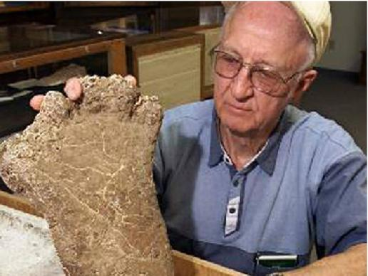
Authentic or not, footprints and other physical artifacts are meaningless scientifically, says Radford, when there is no standard to measure them by.
"Some of the footprints have three toes, some have four toes, and some of course have five," he noted. "Even if I'm certain a certain track wasn't made by anything else, how do I know it's Bigfoot? You can't."
Getty images

The same goes for DNA. Scientists make a positive identification by comparing an unknown sample to a known one. There is no such standard for Bigfoot, says Radford. Even an educated guess about the giant footprint pictured here or a Blobsquatch gone wild is, at best, a shot in the dark.
Getty Images

Benjamin Radford is the co-author of "Lake Monster Mysteries: Investigating the World's Most Elusive Creatures."
Retrieved 1 February 2015

5. Part A
Which definition below best means the same as rattle off as it is used in paragraph 2?
- The elements at the end of the tail of certain snakes
- To give out a series of short, sharp sounds
- To state or perform effortlessly, often at great length
- To chatter mindlessly and at a rapid pace of speed

Part B
Which phrase from the text best supports the answer in Part A?
- “They were storing the body of Bigfoot in the freezer”
- “Is the legend little more than a stubborn myth”
- “First on his list: the fossil record”
- “There’s simply nothing there”

6. Part A
Read these lines from the website text below.
Radford calls it a “Blobsquatch.” Aside from eyewitness reports, blurry images like this are what most Bigfoot believers rely on.

How do these lines help develop an important idea of the text?
- They remind those searching for Bigfoot to use good camera equipment.
- They offer evidence that Bigfoot does exist in areas that have few humans.
- They show that there are many people who believe that Bigfoot is a reality.
- They tell the reader that the evidence that for the existence Bigfoot is weak.

Part B
What other line/s below serves a similar purpose as in Part A?
- “Why, when there are countless researchers probing the far corners of every continent, is there no rigorous, documented, peer-reviewed evidence for Bigfoot?”
- “But scientists are notoriously good note-takers, Radford points out, even about subjects they aren't directly studying.”
- "Even if I'm certain a certain track wasn't made by anything else, how do I know it's Bigfoot? You can't."
- “An alleged vial of Bigfoot blood once turned out to be transmission fluid, and many Bigfoot sightings, in the end, are admitted fakes.”

7. Part A
Which sentence best states an important, or central, idea from “10 Reasons Why Bigfoot’s a Bust?”
- There is not enough solid, scientific evidence to prove the existence of Bigfoot.
- While some evidence has been shown to be hoaxes, there is proof of the existence of Bigfoot.
- There have been several well-funded expeditions to find evidence of the existence of Bigfoot.
- Some scientists are looking for evidence of the Bigfoot while they are searching for other creatures.

Part B
Which detail from the article provides the best example of a central idea in Part A?
- “They were well-equipped, well-funded and made a sustained search.”
- “Some of the footprints have three toes, some have four toes, and some five.”
- “The problem is that’s not evidence, it’s an anecdote…it’s interesting.”
- “Why would a legacy of large mammals simply disappear from the soil?”

8. What are advantages and disadvantages of this format to present information? Use this graphic organizer to organize your thoughts about the advantages/disadvantages of the format of this form of media.

10 Reasons Why Bigfoot’s a Bust

Media format

 | Evidence/Detail or Image | Explanation/Importance
Advantages of this format to presenting information | 1:
Advantages of this format to presenting information | 2:
Advantages of this format to presenting information | 3:
Disadvantages of this format to presenting information | 1:
Disadvantages of this format to presenting information | 2:
Disadvantages of this format to presenting information | 3:

TEXT 3

Read the two articles. Then answer questions 9 – 11.

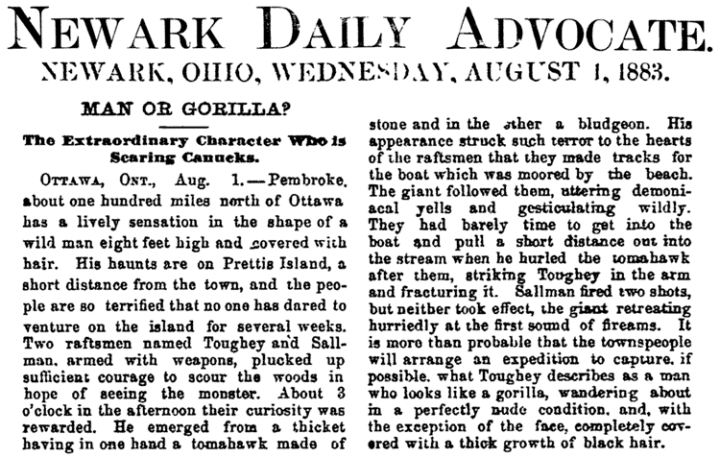
Retrieved from http://www.bigfootencounters.com/articles/prettis_island.htm
5 February 2015

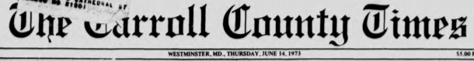
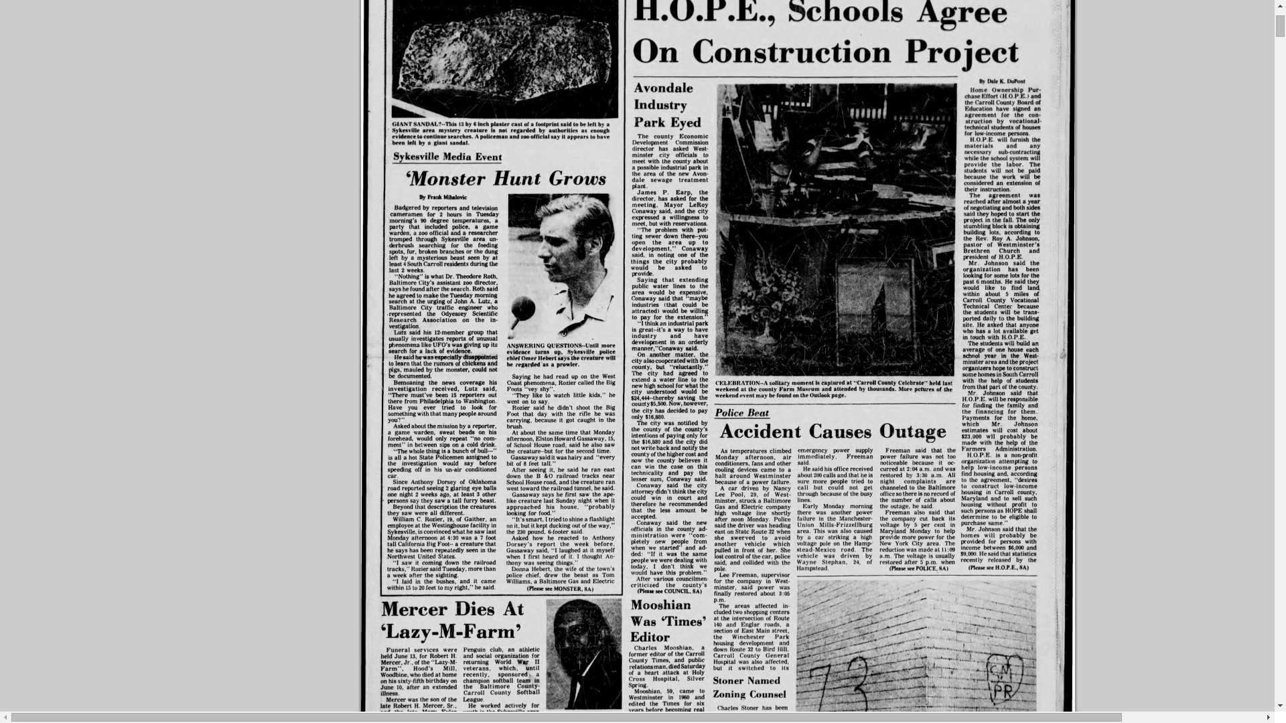
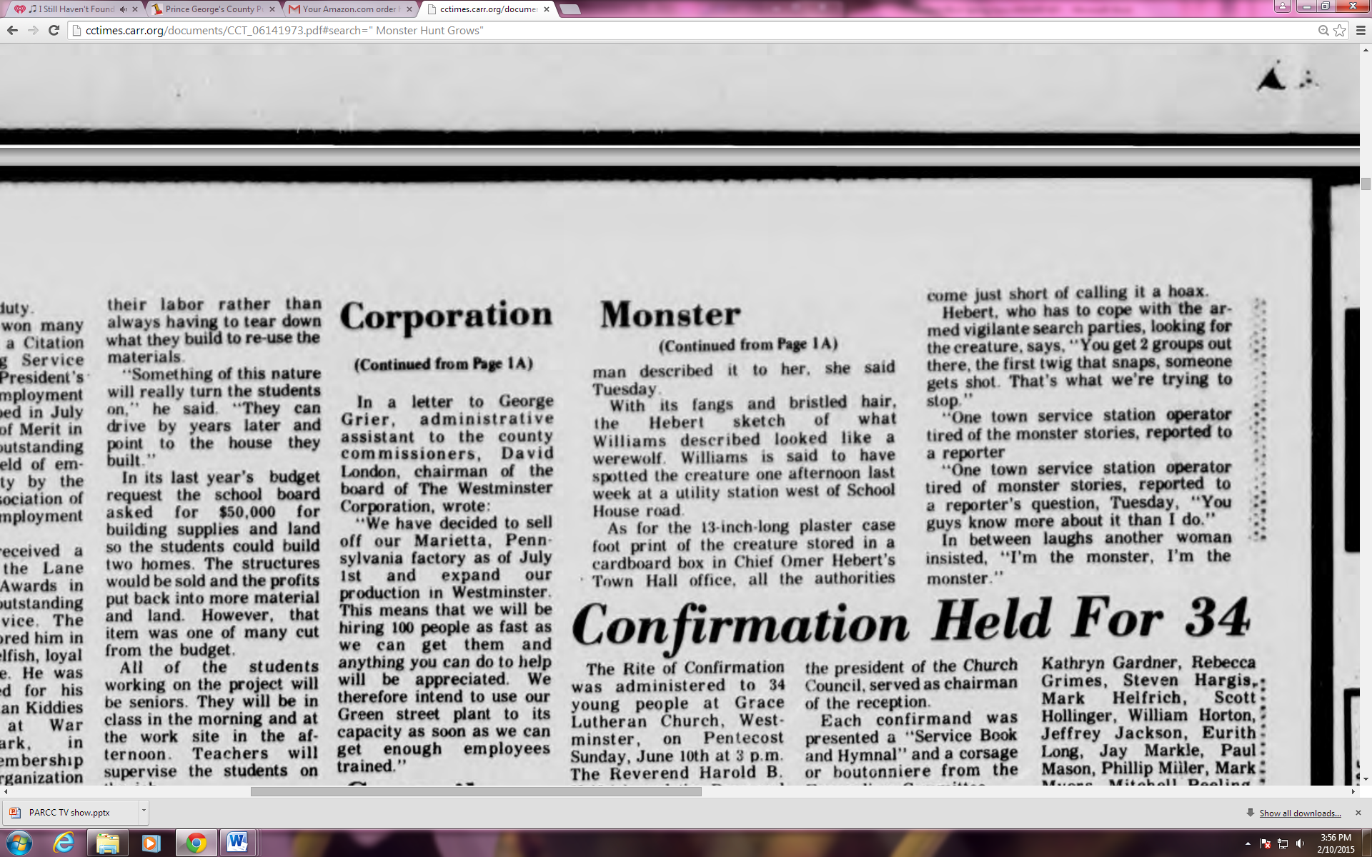

Retrieved from http://cctimes.carr.org/documents/CCT_06141973.pdf#search=" Monster Hunt Grows"
6 February 2015

9. Part A
What point of view does the reporter present in “Man or Gorilla?”
- He is upset by the appearance of this unknown beast.
- He is anxious to discover the identity of the creature seen.
- He is concerned for the safety of those living in Ottawa.
- He is excited by the mystery brought by this “wild man.”

Part B
Which pair of phrases best supports the answer in Part A?
- Extraordinary character; lively sensation
- Two rafts men; sufficient courage
- Demonical yells; gesticulating wildly
- Completely covered; thick growth

10. Part A
What point of view does the reporter present in “Monster Hunt Grows?”
- The reporter remains neutral throughout the article.
- He believes this is solid evidence of a Bigfoot sighting.
- The reporter is hot and uncomfortable during the investigation.
- He thinks that one of the residents has planned a big joke.

Part B
Which phrase from the article best supports the answer in Part A?
- “In between laughs, another woman insisted, “I’m the monster, I’m the monster.”
- “It’s smart. I tried to shine a flashlight on it, but it kept ducking out of the way.”
- “Asked about the mission by a reporter, a game warden would only repeat ‘no comment.’”
- “Lutz said his 12-member group…was giving up its search or a lack of evidence.”

11. What are advantages and disadvantages of this format to present information? Use this graphic organizer to organize your thoughts about the advantages/disadvantages of the format of this form of media.

“Man or Gorilla” and
“Monster Hunt Grows”

Media format

 | Evidence/Detail or Image | Explanation/Importance
Advantages of this format to presenting information | 1:
Advantages of this format to presenting information | 2:
Advantages of this format to presenting information | 3:
Disadvantages of this format to presenting information | 1:
Disadvantages of this format to presenting information | 2:
Disadvantages of this format to presenting information | 3:

Analysis Project

You have learned information about experiences with and evidence (or lack of) of the creature called Bigfoot in these three text sets:
- Encyclopedia entries from Encyclopedia Britannica Online and Wikipedia;

“10 Reasons Why Bigfoot's a Bust;” and

Newspaper articles “Man or Gorilla” and “Monster Hunt Grows.”

For your project, assess and evaluate the advantages and disadvantages of one text media format over another.

HINTS: What are the available media formats to choose from for this RST? What are the advantages and disadvantages of each format? Is one format better than the other? So what—or why is this important?

Support your response with relevant textual, graphic, or visual evidence from each source to support your ideas.

You can produce your response to the above prompt through the following methods.
- Multi-paragraph Essay – may type or write your response
- Prezi – https://prezi.com/signup/public/
- Google Slides – available through your PGCPS Gmail account (similar tools are PowerPoint and Keynote)
- Website – available through your PGCPS Gmail account
- Brochure/Pamphlet
- Mock Interview with an “Expert” – videotaped or done in class after the break
- Mock news broadcast (like a “60 Minutes” or “Dateline” segment) – videotaped to share with your classmates

