Grade 4
Science
SPRING ENRICHMENT PACKET



Prince George’s County Public Schools
Office of Academic Programs
Department of Curriculum and Instruction

Note to Student and Parents/Guardians

This is an “at-home” supplemental science instructional packet for middle school students during Spring Break.

This packet has been created to provide practice for students to answer Selected Response (SR) items and work through technical reading passages of informational text to write Constructed Responses (CRs) to support middle school science and the PGCPS Literacy Initiative. For Constructed Response items, it is highly recommended that students practice their annotating skills when reading the text.

Students will use the passages to write claims, evidence, and reasoning for Constructed Response items and circle the correct answer choice for Selected Response items.

- For more information about the PGCPS Literacy Initiative, visit: http://www.pgcps.org/literacy/ for parents and students.

The items in the Spring Enrichment Packet are aligned to the Next Generation Science Standards’ (NGSS) Science and Engineering Practices (SEPs), physics and chemistry.

For more information about the PGCPS Science and NGSS, visit:
- PGCPS Science Department: http://www1.pgcps.org/science/
- NGSS Website: https://www.nextgenscience.org/
- NGSS Parent Guide: https://tinyurl.com/NGSSParentGuide

The answer key for SR items and the writing rubric for CR items are located on pages 9 and 10.
.

Water On Earth
Where can you find water? You might say an ocean, a lake, a river, or even in the air. Water is a common liquid. However, you can also find water as a solid. Ice is water that is frozen into a solid. Snow and hail are made of ice.
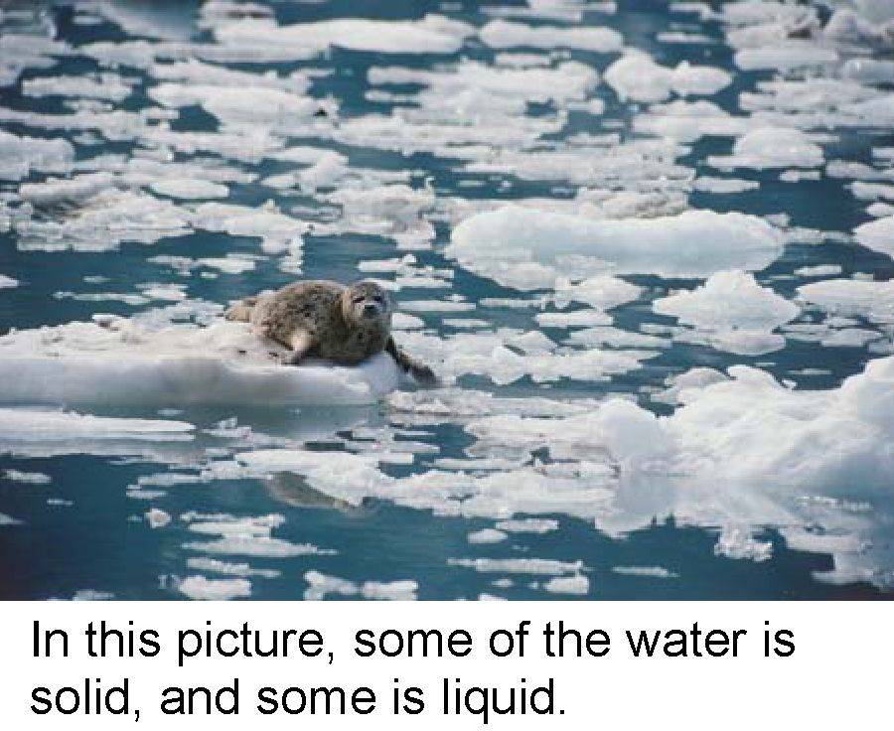

You can even find water as an invisible gas called vapor. Water vapor is in the air all around us.

Whether water is a solid, liquid, or gas depends partly on temperature. For example, if the temperature is low enough, then water is a solid. Think about the North Pole. Temperatures there rarely get above 0o C (32oF). It is so cold that the seawater is frozen, even during the summer.

Next, think about the water near the equator. Here, the temperatures are mild throughout the year. The average daily temperature is around 24oC (75oF). The water is always warm in this part of the world. Ice never forms in these waters.
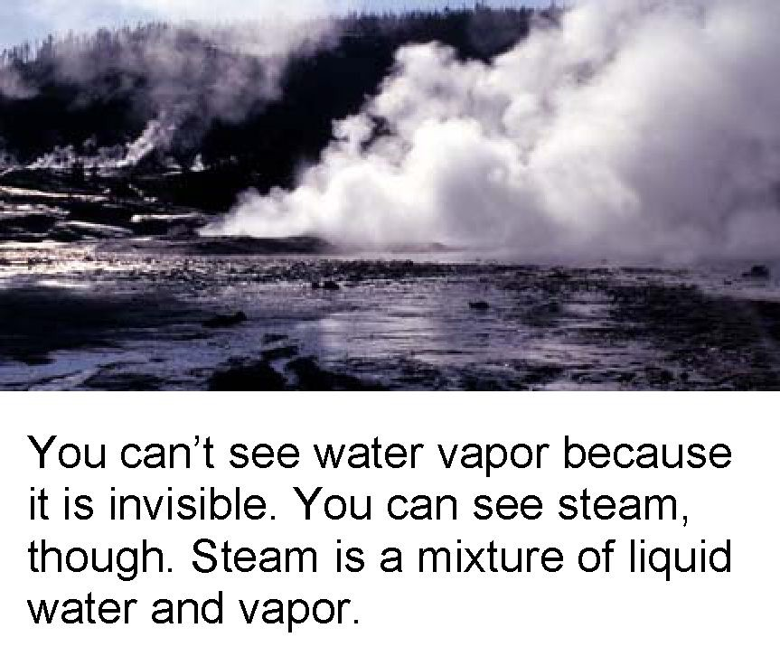

Now think of a volcano on an island. The volcano has just erupted. As hot lava pours into the ocean, the water heats up so much that it boils. It turns into an invisible gas that rises into the air.

Even in an ocean, you can find water as a solid, a liquid, or a gas. You just have to look in the right place.

Discovery Education Science © 2007 Discovery Communications, LLC

1. Use the reading passage, “Water on Earth” to create a table or chart of the different forms of water and where they can be located on Earth. Be sure to title your table or chart and label columns and rows.

2. A student heated a pan of soup on a stove. While stirring the soup with a metal spoon, the student noticed the spoon became very warm.
What is the most likely reason the spoon became warm?
- The stirring action heated the spoon.
- Warm air in the room heated the spoon.
- Heat from the soup heated the spoon.
- The student's hand transferred heat to the spoon.

3. Some objects are attracted by magnets. Which object is attracted by a magnet?
- an iron nail  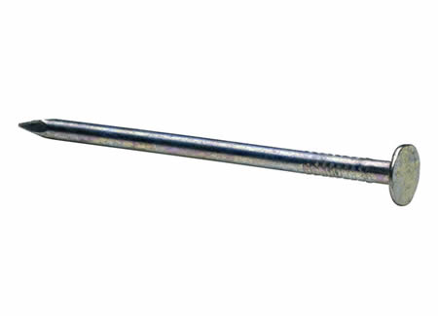 | - an ice cube  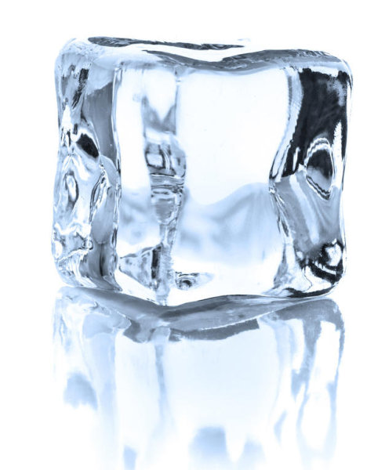
  - a plastic knife | D. a wooden ruler  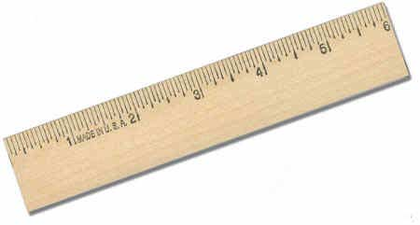

4. A girl makes a cup of hot chocolate, but the hot chocolate is too hot. She places an ice cube in the cup.

Which of the following best describes what happens when the hot chocolate comes in contact with the ice cube?

A. the ice cube loses heat
B. the hot chocolate gains heat
C. the hot chocolate loses heat and the ice cube gains heat
D. the ice cube loses heat and the hot chocolate gains heat

5. What is not considered to be a form of matter?

A. air
B. ice
C. light

D. water

6. What tool can be used to measure the distance a toy car travels after being pushed down the ramp?

A. barometer
B. meter stick
C. stop watch
D. thermometer
Moving Along

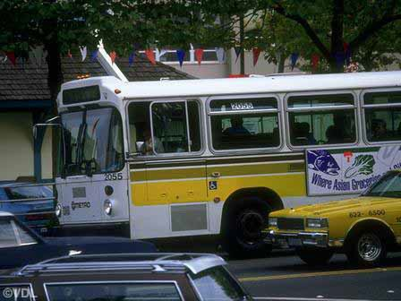
Finding out if an object is moving should be very simple. All you have to do is look at the object. Well, it’s not always that simple. Imagine that you are riding on a bus. You look out the window at a car in the next lane. The car does not seem to be moving. This is because the car is traveling just as fast as you are.

The car and the bus are both in motion. Motion is a change in the position of an object. You know an object's position by knowing where it is. So, an object is in motion if it moves from one place to another place. A ball rolling along the ground is in motion. The car and the bus are in motion because they are moving from one place to another.

To tell if an object is in motion, you must be able to tell if it is moving from one place to another. To do this, you have to look at two different objects at the same time. You look at one object that is not moving. You compare the other object to this object. For example, to tell if the car is moving, you would look at the car. You would also look at the road or a tree, neither of which is moving. Then you could tell that the car was moving because you could see that its position was changing.

Discovery Education Science © Discovery Communications, LLC

7. Use the reading passage, “Moving Along”, to explain how to determine if
an object is in motion.

Answer Key

# Item | Answer
1 | Students’ charts or tables will vary. Please ensure that the students have a title, identify the forms of water and document where the forms of waters can be found on Earth in their designs.
2 | C
3 | A
4 | C
5 | C
6 | B
7 | USE THE WRITING RUBRIC ON PAGE 10 TO SCORE  Example Answer: Motion is the change in the position of the objects. A ball rolling along the ground is in motion. A car is in motion when it is moving from one place to another. You can tell a car is moving because you can see the car’s position is changing.

MISA 4-POINT RUBRIC
Rubric derived from the Maryland State Department of Education for use with Maryland Integrated Science Assessment (MISA).

Score Point 4
There is evidence in this response that the student has a full and complete understanding of the solution to a problem or constructs a full and complete explanation of the question.
- Demonstrates complete integration of the use of science and engineering practices such as modeling, engaging in argument from evidence, obtaining, evaluating, and communicating information, etc.
- Provides a solution or explanation that is coherent and based on disciplinary core ideas
- Reflects a complete synthesis of understanding of complex ideas and crosscutting concepts
- Includes an effective application of the 3 dimensions (SEP, DCI, and CCC) to a practical problem or real-world situation which demonstrates a complete understanding of the 3 dimensions
Score Point 3
There is evidence in this response that the student has a general understanding of the solution to a problem or constructs a complete explanation of the question.
- Demonstrates integration of the use of science and engineering practices such as, modeling, engaging in argument from evidence, obtaining, evaluating, and communicating information, etc.
- Provides a solution or explanation that is mostly coherent and based on disciplinary core ideas
- Reflects a synthesis of understanding of complex ideas and crosscutting concepts
- Includes an effective application of the 3 dimensions to a practical problem or real-world situation which demonstrates an understanding of the 3 dimensions

Score Point 2
There is evidence in this response that the student has a partial understanding of the solution to a problem or constructs an explanation of the question.
- Demonstrates some integration of the use of science and engineering practices such as, modeling, engaging in argument from evidence, obtaining, evaluating, and communicating information, etc.
- Provides a solution or explanation that is adequately coherent and based on disciplinary core ideas
- Reflects some synthesis of understanding of complex ideas and crosscutting concepts
- Includes an application of the 3 dimensions to a practical problem or real-world situation which demonstrates a partial understanding of the 3 dimensions

Score Point 1
There is evidence in this response that the student has a minimal understanding of the solution to a problem or constructs a minimal explanation of the question.
- Demonstrates little or no integration of the use of science and engineering practices such as, modeling, engaging in argument from evidence, obtaining, evaluating, and communicating information, etc.
- Provides a solution or explanation that is minimally based on disciplinary core ideas
- Reflects little or no synthesis of understanding of complex ideas and crosscutting concepts
- Includes an application of the 3 dimensions to a practical problem or real-world situation which demonstrates a minimal understanding of the 3 dimensions

Score Point 0
There is evidence that the student has no understanding of the solution to a problem or the question.
- The response is completely incorrect, too vague, or irrelevant to the solution or question

